**Unit 7**

**Procedures and precautions**

**Lesson 2 (p. 55)**

**Ex. 3. A. B. C.: All three exercises discuss the dangers and the required precautions when working inside a silo.**

**First, what is a silo?**

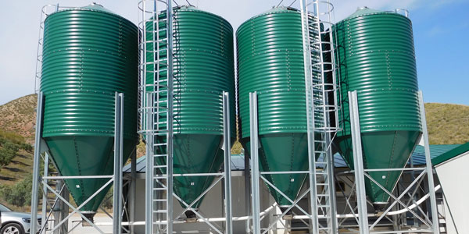

A silo is a storage house for storing grains as wheat, rice, corn…etc.

It is a **CONFINED SPACE,** as it has no doors or windows.

So,

What dangers do workers face when doing welding inside a silo?

What precautions should be followed to keep workers safe?

(this is found in text 7. 2)

**1. When accessing the silo:**

**A. There is the danger of falling off the external ladders, or down the internal stairs.**

The precaution:

Ladders need protective hoops around them

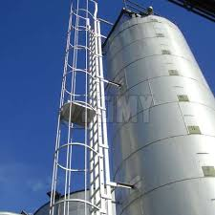

Stairs need guard rails.

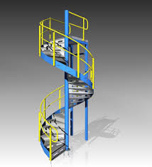

**B. There is the danger of equipment falling onto someone.**

**The precaution:**

Use smaller sized welding bottles.

Lower and raise the equipment using ropes instead of workers carrying them.

**2. When working inside the silo**

**A. A silo is a confined space, so there is the danger of suffocation.**

**The precaution:**

Workers must test the air before entering.

Workers must use a CO2 detector all the time

**B. While welding, there is the danger of suffocation because of welding fumes.**

**The precaution:**

Workers can use an air extractor (ventilator)

**C. There is the danger of fire or explosion because welding causes sparks.**

**Vocabulary items: (p55 and text 7.2)**

Hazard analysis: predicting/ expecting/ evaluating dangers

Interior: inside

Exterior: outside

Approx. (approximately): almost

Access: getting into

Risk: danger

Permanent: there all the time

Air ventilation: air extraction/ air circulation

**After you study lesson 1 and lesson 2, please do the following exercise.**

**Fill in the spaces with words from the given list: (answers are on the next page)**

**access / emergency exits / irritant / sparks / corrosive / hazardous / ventilation / noise / guards / confined / guardrails / flammable / asphyxiation / exposure / precaution**

1. _______________ spaces are areas with no or limited air circulation.

2. Asbestos is a ____________ material. It can cause cancer.

3. Welding inside this factory is dangerous. They make _____________ liquids.

4. People have________________ systems in kitchens to extract smell of cooking.

5. It is dangerous to stay inside the container for a long time. You might face the danger of ______________.

6. When cutting pieces of metal, ____________ can cause the danger of fires.

7. This material is _______________. It caused my skin to react.

8. You need to wear ear protections when there is __________ hazard.

9. I received a message on my computer saying "No internet __________". I couldn't open any page.

10. Seat belts in cars are used as a _________________ against injuries.

11. We fixed ____________ on the roof to prevent the children from falling.

12. This machine has dangerous sharp parts, so it needs ______________ around it.

13. When you hear the fire alarm, immediately go to the nearest ______________.

14. _____________ to harmful substances can cause skin to react.

15. Acid is a _____________ material. It burns the skin.

Answers:

Confined / hazardous / flammable / ventilation / asphyxiation / sparks /

irritant / noise / access / precaution / guardrails /guards /

emergency exits / exposure corrosive